Mrs. Rogge’s Class
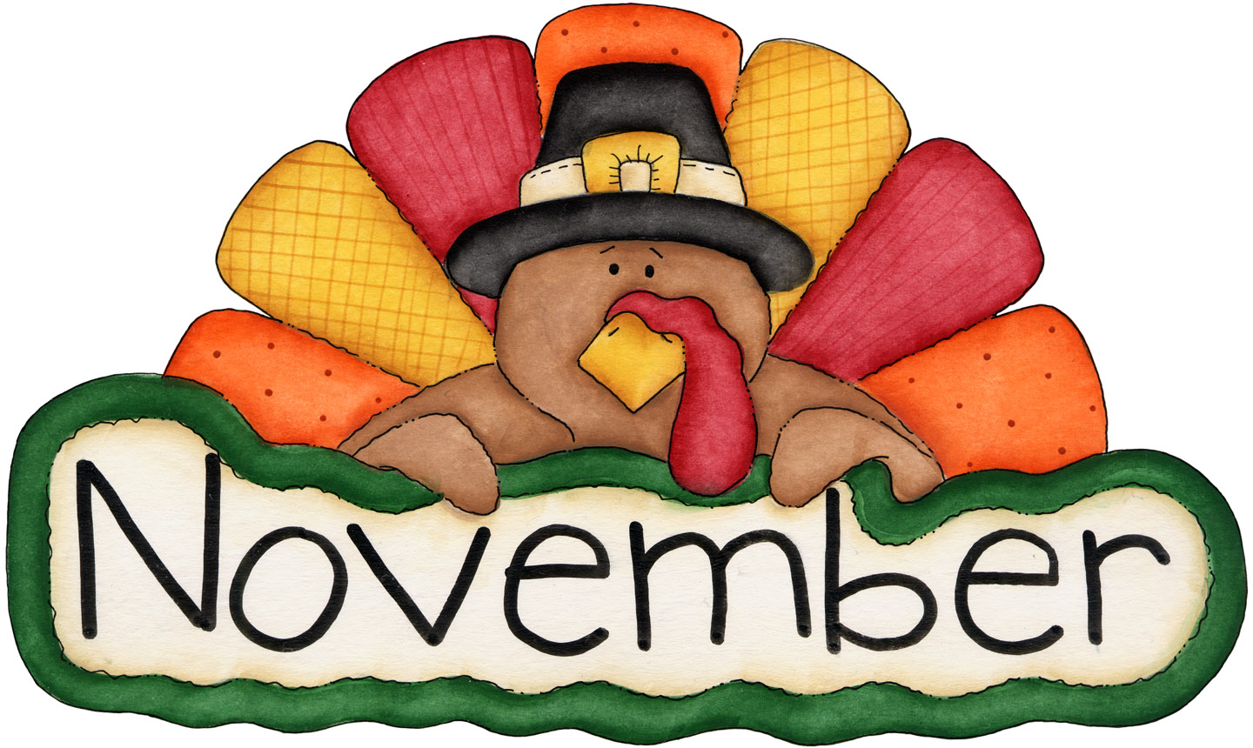
- Please send enough pre-portioned snacks for 20 scholars. Thank you! (Don’t forget spoons if necessary!)
- Your child will also be the classroom “Noodle Master” on this day!

Sunday |  | Monday |  | Tuesday |  | Wednesday | Thursday | Friday |  | Saturday
28 | 29  Ella |  | 30  Leo |  | 31  Hattie |  | 1  Huck |  | 2  Davis  Haunting Tales  6:30-8pm |  | 3  Great Gathering  7-10pm
4 | 5  Vinny |  | 6  Louis |  | 7  Happy B-day!  Elisa |  | 8  Amira |  | 9  Gus |  | 10
11 | 12  Keagan |  | 13  Parent Day  Vera |  | 14  Grace |  | 15  Happy B-day!  Leo  Evening Conferences |  | 16  Ben |  | 17
18  Happy Birthday Ben! | 19 |  | 20  Conferences  (8-4 pm) |  | 21  NO SCHOOL |  | 22  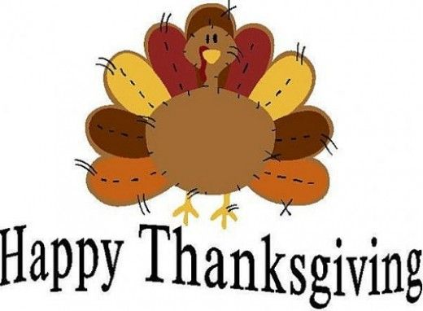 |  | 23 |  | 24
25 | 26  Zana |  | 27  William |  | 28  Gabriel |  | 29  Addy |  | 30  Virtue Assembly  9:00am  Calista |  | December 1
2 | 3  Gretchen |  | 4  Hattie |  | 5  Huck |  | 6  Davis |  | 7  Vinny |  | 8

